Top of Form

Bottom of Form

Top of Form

Bottom of Form

facebook.com

**Domain Information**

Domain:

facebook.com

Registrar:

RegistrarSafe, LLC

Registered On:

1997-03-29

Expires On:

2031-03-30

Updated On:

2022-01-26

Status:

clientDeleteProhibited  
clientTransferProhibited  
clientUpdateProhibited  
serverDeleteProhibited  
serverTransferProhibited  
serverUpdateProhibited

Name Servers:

a.ns.facebook.com  
b.ns.facebook.com  
c.ns.facebook.com  
d.ns.facebook.com

**Registrant Contact**

Name:

Domain Admin

Organization:

Meta Platforms, Inc.

Street:

1601 Willow Rd

City:

Menlo Park

State:

CA

Postal Code:

94025

Country:

US

Phone:

+1.6505434800

Email:

email@fb.com

**Administrative Contact**

Name:

Domain Admin

Organization:

Meta Platforms, Inc.

Street:

1601 Willow Rd

City:

Menlo Park

State:

CA

Postal Code:

94025

Country:

US

Phone:

+1.6505434800

Email:

email@fb.com

**Technical Contact**

Name:

Domain Admin

Organization:

Meta Platforms, Inc.

Street:

1601 Willow Rd

City:

Menlo Park

State:

CA

Postal Code:

94025

Country:

US

Phone:

+1.6505434800

Email:

email@fb.com

**Raw Whois Data**

Domain Name: FACEBOOK.COM

Registry Domain ID: 2320948_DOMAIN_COM-VRSN

Registrar WHOIS Server: whois.registrarsafe.com

Registrar URL: https://www.registrarsafe.com

Updated Date: 2022-01-26T16:45:06Z

Creation Date: 1997-03-29T05:00:00Z

Registrar Registration Expiration Date: 2031-03-30T04:00:00Z

Registrar: RegistrarSafe, LLC

Registrar IANA ID: 3237

Registrar Abuse Contact Email: email@registrarsafe.com

Registrar Abuse Contact Phone: +1.6503087004

Domain Status: serverUpdateProhibited https://www.icann.org/epp#serverUpdateProhibited

Domain Status: clientDeleteProhibited https://www.icann.org/epp#clientDeleteProhibited

Domain Status: clientTransferProhibited https://www.icann.org/epp#clientTransferProhibited

Domain Status: serverDeleteProhibited https://www.icann.org/epp#serverDeleteProhibited

Domain Status: serverTransferProhibited https://www.icann.org/epp#serverTransferProhibited

Domain Status: clientUpdateProhibited https://www.icann.org/epp#clientUpdateProhibited

Registry Registrant ID:

Registrant Name: Domain Admin

Registrant Organization: Meta Platforms, Inc.

Registrant Street: 1601 Willow Rd

Registrant City: Menlo Park

Registrant State/Province: CA

Registrant Postal Code: 94025

Registrant Country: US

Registrant Phone: +1.6505434800

Registrant Phone Ext:

Registrant Fax:

Registrant Fax Ext:

Registrant Email: email@fb.com

Registry Admin ID:

Admin Name: Domain Admin

Admin Organization: Meta Platforms, Inc.

Admin Street: 1601 Willow Rd

Admin City: Menlo Park

Admin State/Province: CA

Admin Postal Code: 94025

Admin Country: US

Admin Phone: +1.6505434800

Admin Phone Ext:

Admin Fax:

Admin Fax Ext:

Admin Email: email@fb.com

Registry Tech ID:

Tech Name: Domain Admin

Tech Organization: Meta Platforms, Inc.

Tech Street: 1601 Willow Rd

Tech City: Menlo Park

Tech State/Province: CA

Tech Postal Code: 94025

Tech Country: US

Tech Phone: +1.6505434800

Tech Phone Ext:

Tech Fax:

Tech Fax Ext:

Tech Email: email@fb.com

Name Server: C.NS.FACEBOOK.COM

Name Server: B.NS.FACEBOOK.COM

Name Server: A.NS.FACEBOOK.COM

Name Server: D.NS.FACEBOOK.COM

DNSSEC: unsigned

URL of the ICANN WHOIS Data Problem Reporting System: http://wdprs.internic.net/

>>> Last update of WHOIS database: 2022-06-09T10:59:20Z <<<

Search results obtained from the RegistrarSafe, LLC WHOIS database are

provided by RegistrarSafe, LLC for information purposes only, to assist

users in obtaining information concerning a domain name registration record.

The information contained therein is provided on an "as is" and "as available"

basis and RegistrarSafe, LLC does not guarantee the accuracy or completeness

of any information provided through the WHOIS database. By submitting a WHOIS query,

you agree to the following: (1) that you will use any information provided through

the WHOIS only for lawful purposes; (2) that you will comply with all ICANN rules

and regulations governing use of the WHOIS; (3) that you will not use any information

provided through the WHOIS to enable, or otherwise cause the transmission of mass

unsolicited, commercial advertising or solicitations via e-mail (i.e., spam); or

(4) that you will not use the WHOIS to enable or otherwise utilize high volume,

automated, electronic processes that apply to or attach to RegistrarSafe, LLC or

its systems. RegistrarSafe, LLC reserves the right to modify these terms

at any time and to take any other appropriate actions, including but not limited to

restricting any access that violates these terms and conditions. By submitting this

query, you acknowledge and agree to abide by the foregoing terms, conditions and policies.

For more information on Whois status codes, please visit

https://www.icann.org/resources/pages/epp-status-codes-2014-06-16-en.

**WAYBACK ( FACEBOOK)**

**December 10 2008**

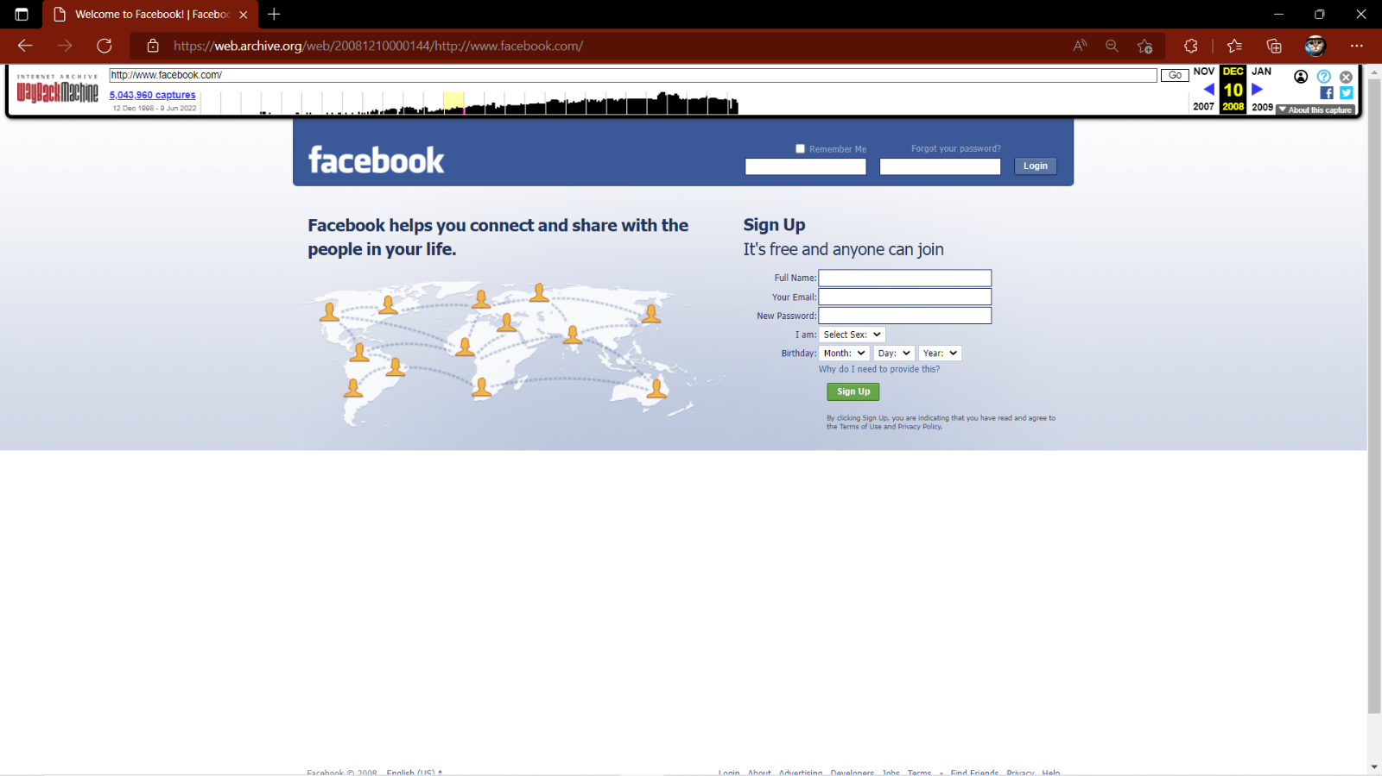

**November 1 2012**

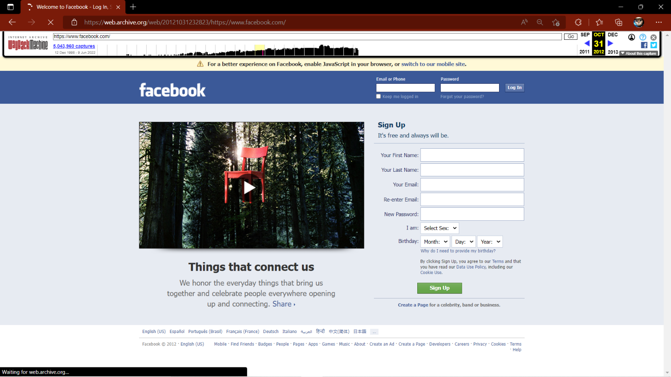

**December 1 2018**

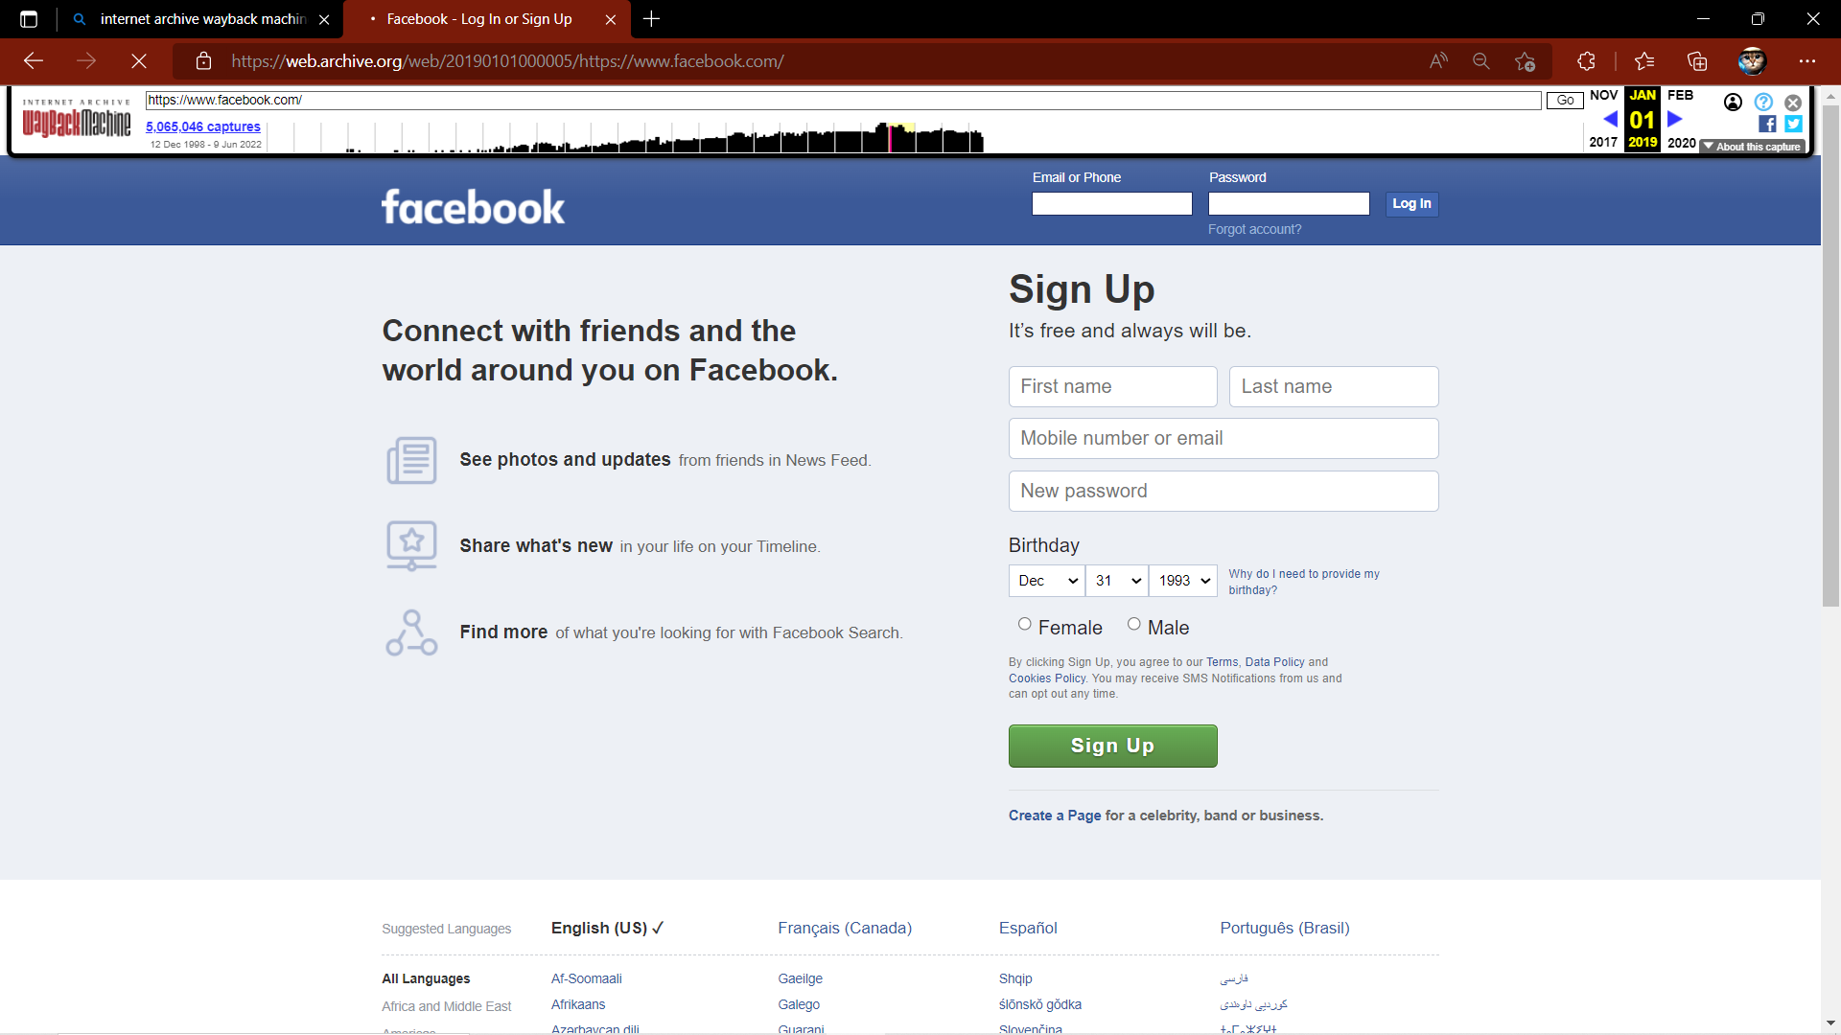

**May 1 2022**

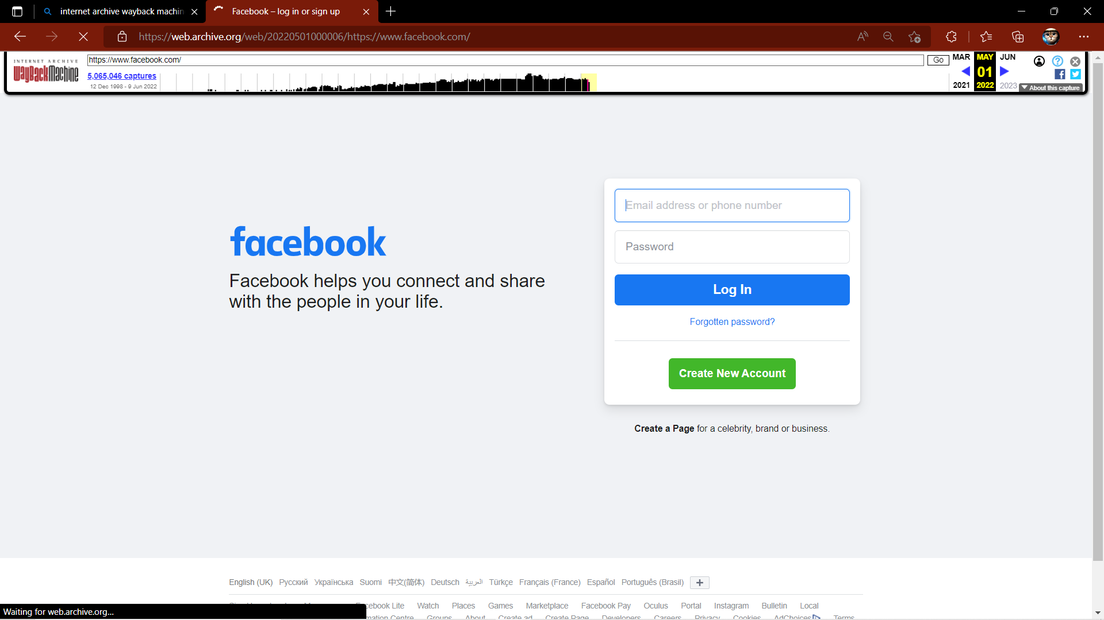

**TWITTER.COM**

**Domain Information**

Domain:

twitter.com

Registrar:

CSC Corporate Domains, Inc.

Registered On:

2000-01-21

Expires On:

2023-01-21

Updated On:

2022-01-17

Status:

clientTransferProhibited  
serverDeleteProhibited  
serverTransferProhibited  
serverUpdateProhibited

Name Servers:

a.r06.twtrdns.net  
b.r06.twtrdns.net  
c.r06.twtrdns.net  
d.r06.twtrdns.net  
d01-01.ns.twtrdns.net  
d01-02.ns.twtrdns.net  
ns3.p34.dynect.net  
ns4.p34.dynect.net

**Registrant Contact**

Name:

Twitter, Inc.

Organization:

Twitter, Inc.

Street:

1355 Market Street

City:

San Francisco

State:

CA

Postal Code:

94103

Country:

US

Phone:

+1.4152229670

Fax:

+1.4152220922

Email:

email@twitter.com

**Administrative Contact**

Name:

Domain Admin

Organization:

Twitter, Inc.

Street:

1355 Market Street

City:

San Francisco

State:

CA

Postal Code:

94103

Country:

US

Phone:

+1.4152229670

Fax:

+1.4152220922

Email:

email@twitter.com

**Technical Contact**

Name:

Tech Admin

Organization:

Twitter, Inc.

Street:

1355 Market Street

City:

San Francisco

State:

CA

Postal Code:

94103

Country:

US

Phone:

+1.4152229670

Fax:

+1.4152220922

Email:

email@twitter.com

**Raw Whois Data**

Domain Name: twitter.com

Registry Domain ID: 18195971_DOMAIN_COM-VRSN

Registrar WHOIS Server: whois.corporatedomains.com

Registrar URL: www.cscprotectsbrands.com

Updated Date: 2022-01-17T01:08:20Z

Creation Date: 2000-01-21T11:28:17Z

Registrar Registration Expiration Date: 2023-01-21T16:28:17Z

Registrar: CSC CORPORATE DOMAINS, INC.

Sponsoring Registrar IANA ID: 299

Registrar Abuse Contact Email: email@cscglobal.com

Registrar Abuse Contact Phone: +1.8887802723

Domain Status: clientTransferProhibited http://www.icann.org/epp#clientTransferProhibited

Domain Status: serverDeleteProhibited http://www.icann.org/epp#serverDeleteProhibited

Domain Status: serverTransferProhibited http://www.icann.org/epp#serverTransferProhibited

Domain Status: serverUpdateProhibited http://www.icann.org/epp#serverUpdateProhibited

Registry Registrant ID:

Registrant Name: Twitter, Inc.

Registrant Organization: Twitter, Inc.

Registrant Street: 1355 Market Street

Registrant City: San Francisco

Registrant State/Province: CA

Registrant Postal Code: 94103

Registrant Country: US

Registrant Phone: +1.4152229670

Registrant Phone Ext:

Registrant Fax: +1.4152220922

Registrant Fax Ext:

Registrant Email: email@twitter.com

Registry Admin ID:

Admin Name: Domain Admin

Admin Organization: Twitter, Inc.

Admin Street: 1355 Market Street

Admin City: San Francisco

Admin State/Province: CA

Admin Postal Code: 94103

Admin Country: US

Admin Phone: +1.4152229670

Admin Phone Ext:

Admin Fax: +1.4152220922

Admin Fax Ext:

Admin Email: email@twitter.com

Registry Tech ID:

Tech Name: Tech Admin

Tech Organization: Twitter, Inc.

Tech Street: 1355 Market Street

Tech City: San Francisco

Tech State/Province: CA

Tech Postal Code: 94103

Tech Country: US

Tech Phone: +1.4152229670

Tech Phone Ext:

Tech Fax: +1.4152220922

Tech Fax Ext:

Tech Email: email@twitter.com

Name Server: NS3.P34.DYNECT.NET

Name Server: c.r06.twtrdns.net

Name Server: NS4.P34.DYNECT.NET

Name Server: d01-01.ns.twtrdns.net

Name Server: d.r06.twtrdns.net

Name Server: d01-02.ns.twtrdns.net

Name Server: b.r06.twtrdns.net

Name Server: a.r06.twtrdns.net

DNSSEC: unsigned

URL of the ICANN WHOIS Data Problem Reporting System: http://wdprs.internic.net/

>>> Last update of WHOIS database: 2022-01-17T01:08:20Z <<<

For more information on Whois status codes, please visit https://icann.org/epp

Corporation Service Company(c) (CSC) The Trusted Partner of More than 50% of the 100 Best Global Brands.

Contact us to learn more about our enterprise solutions for Global Domain Name Registration and Management, Trademark Research and Watching, Brand, Logo and Auction Monitoring, as well SSL Certificate Services and DNS Hosting.

NOTICE: You are not authorized to access or query our WHOIS database through the use of high-volume, automated, electronic processes or for the purpose or purposes of using the data in any manner that violates these terms of use. The Data in the CSC WHOIS database is provided by CSC for information purposes only, and to assist persons in obtaining information about or related to a domain name registration record. CSC does not guarantee its accuracy. By submitting a WHOIS query, you agree to abide by the following terms of use: you agree that you may use this Data only for lawful purposes and that under no circumstances will you use this Data to: (1) allow, enable, or otherwise support the transmission of mass unsolicited, commercial advertising or solicitations via direct mail, e-mail, telephone, or facsimile; or (2) enable high volume, automated, electronic processes that apply to CSC (or its computer systems). CSC reserves the right to terminate your access to the WHOIS database in its sole discretion for any violations by you of these terms of use. CSC reserves the right to modify these terms at any time.

Register your domain name at http://www.cscglobal.com

**WAYBACK MACHINE (twitter)**

**February 6 2008**

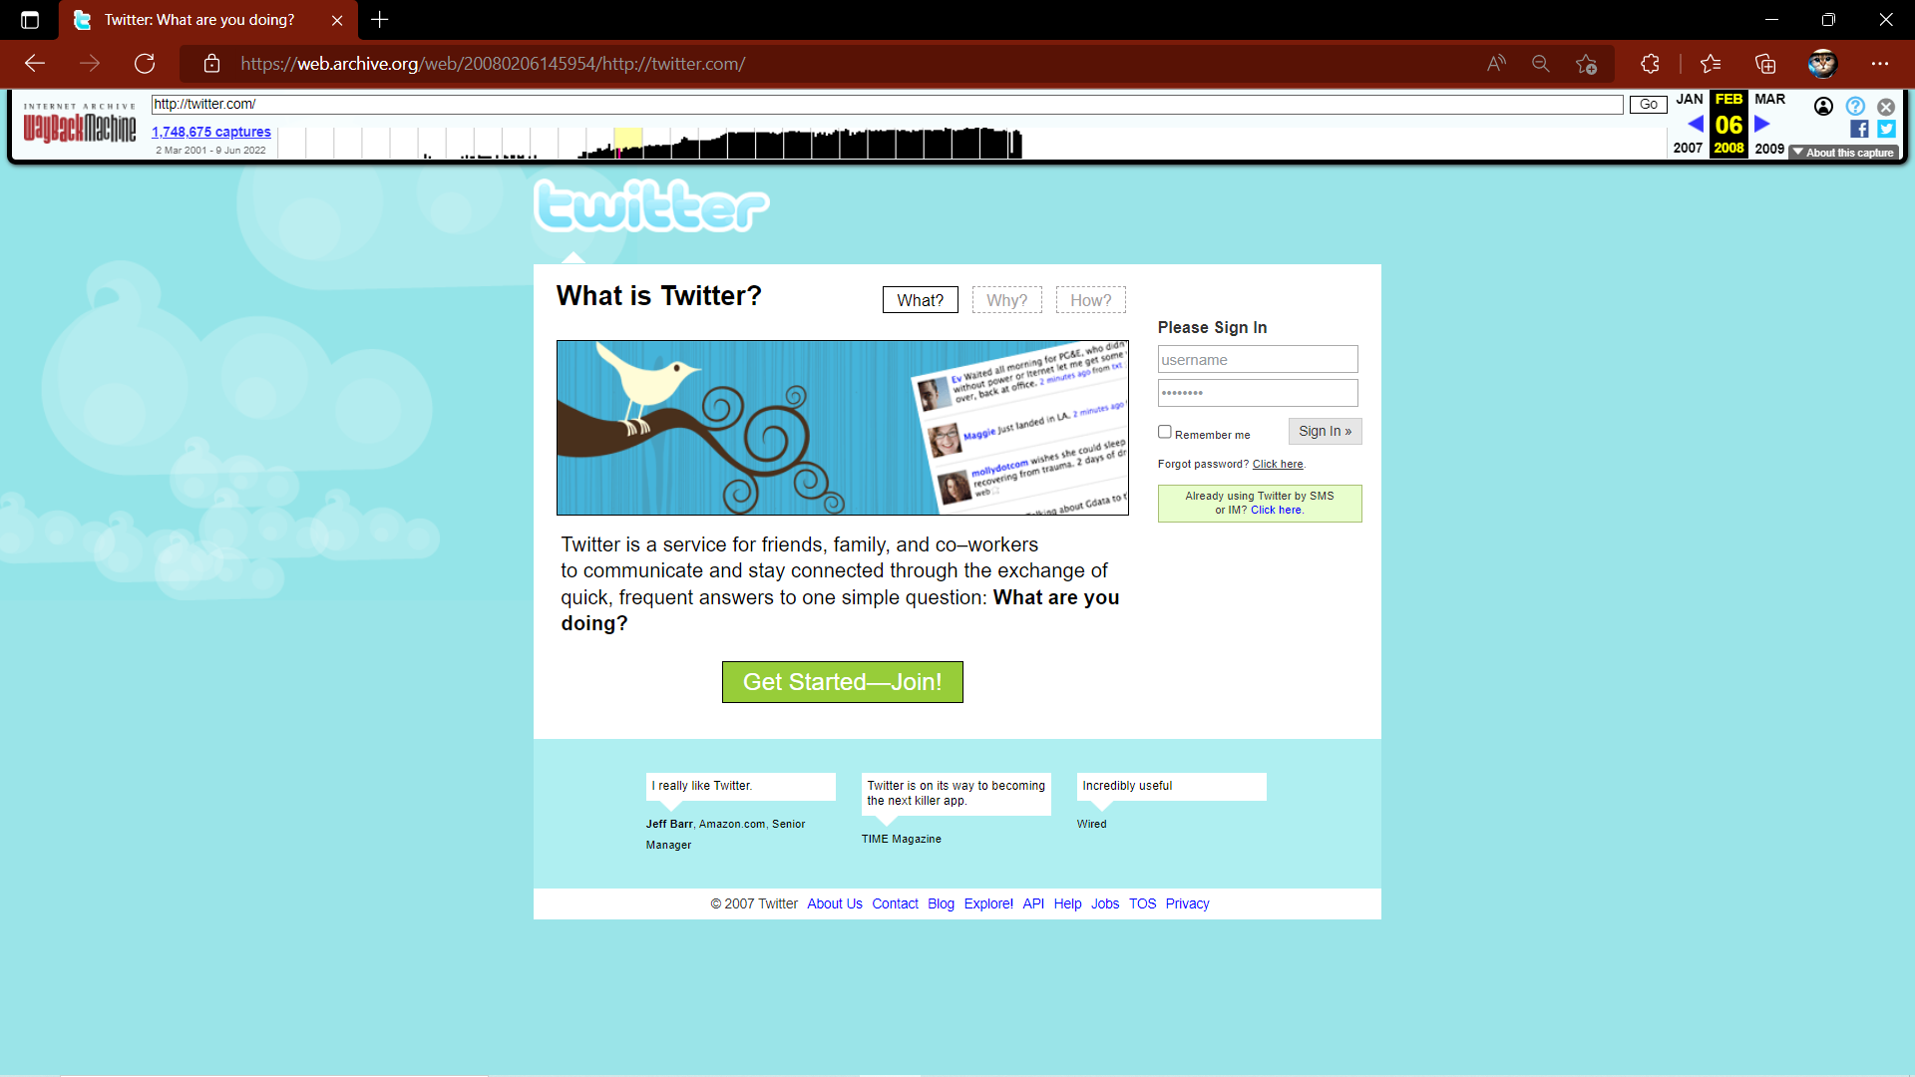

February 6 2012

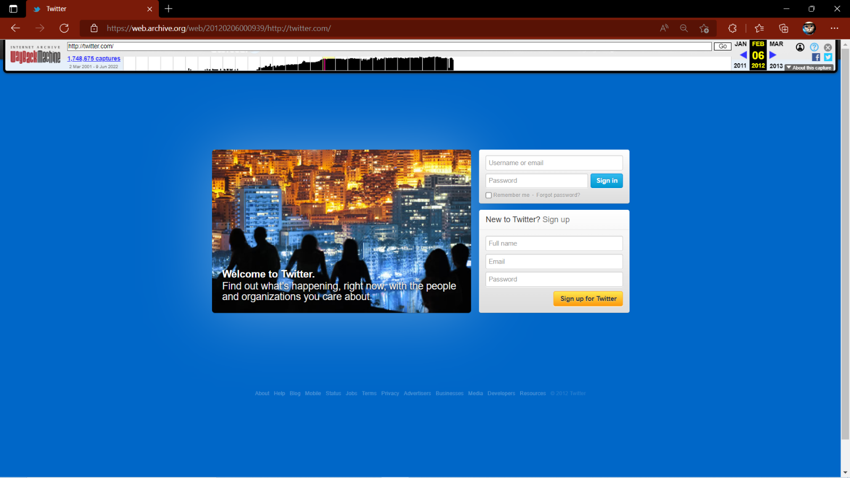

March 29 2018

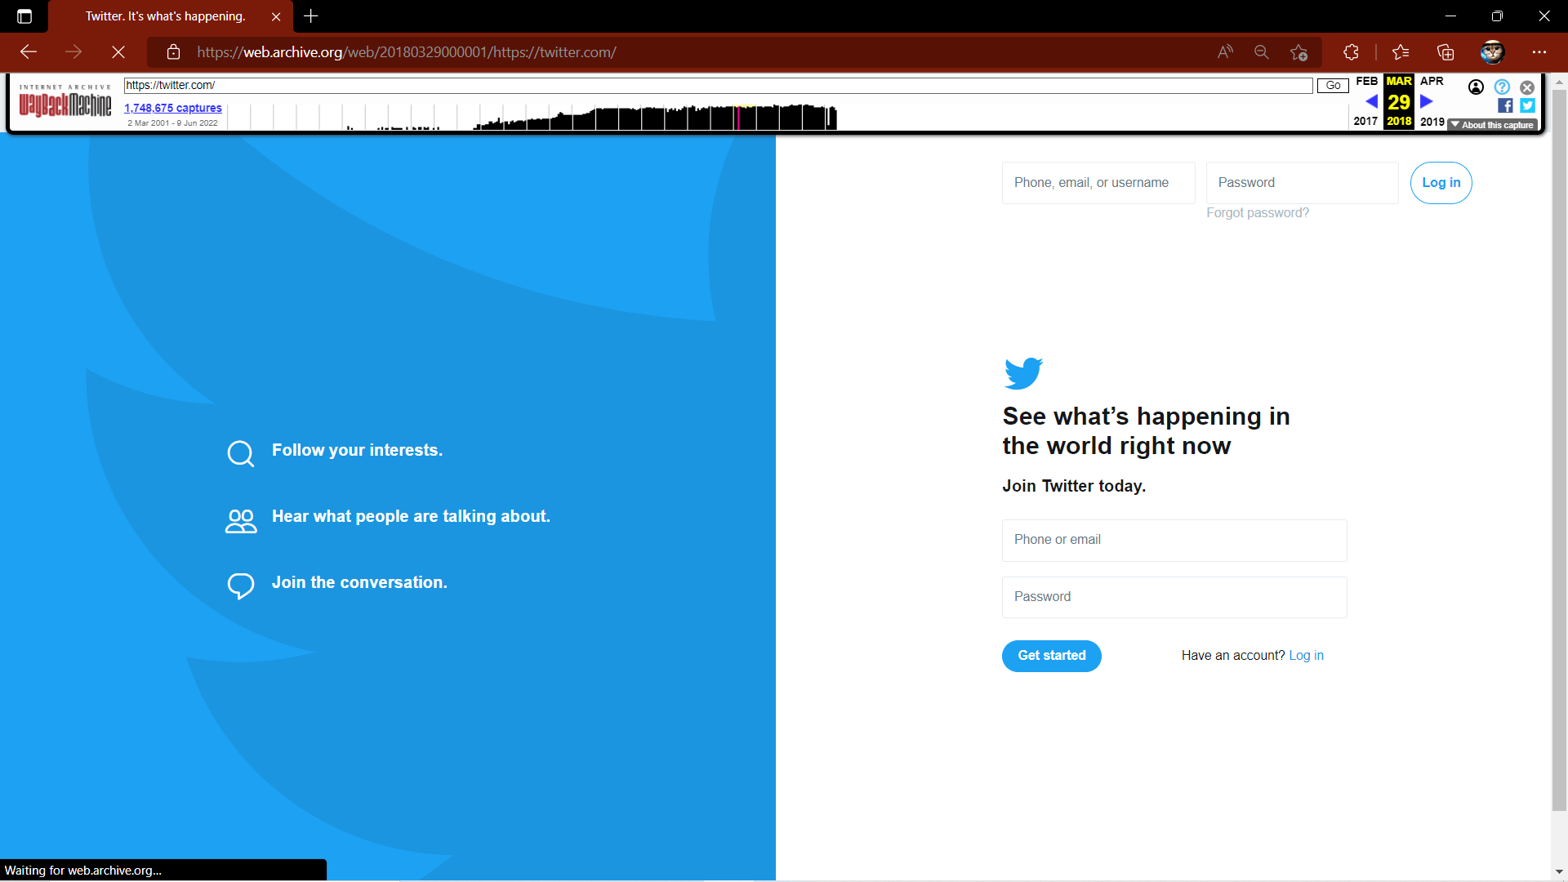

March 31 2022

